User Instruction Document
for
minute_taker
Prepared by
David Rozwod

Table of Contents
Step 1. Download project 2
Step 2. Extract files 2
Step 3. Open project 3
Step 4. Open python file 4
Step 5. Open terminal 5
Step 6. Set up the environment 5
Step 7. Activate the environment 5
Step 8. Install required python packages 6
Step 9. Set up flask app 6
Step 10. Run flask app 6
Step 11. Open website 6
Step 12. Create account 6
Step 13. Login 7
Step 14. Create a new meeting 7
Step 15. View/Delete all meetings 8
Step 16. Logout 8
Step 17. Rerun flask app 8

Step 1. Download project
Download project from GitHub (https://github.com/davidrozwod/minute_taker)

Step 2. Extract files
Extract downloaded zip file

Step 3. Open project
Open project folder from desired IDE (Integrated Development Environment), in this case Microsoft Visual Studio Community 2022.

Step 4. Open python file
Open app.py from Solution Explorer

Step 5. Open terminal
Open Developer Power Shell by pressing Ctrl + ` or from the View menu

Step 6. Set up the environment
Type: py -3 -m venv env (into the terminal)
If this warning pops-up, press Always trust

Step 7. Activate the environment
Type: env\Scripts\activate (into the terminal)

Step 8. Install required python packages
Type: pip install -r requirements.txt (into the terminal)

Step 9. Set up flask app
Type: set FLASK_APP=app.py (into the terminal)

Step 10. Run flask app
Type: flask run (into the terminal)

Step 11. Open website
Right click (to copy) or type http://127.0.0.1:5000 into your browser to open the running website

To close the flask applicaton either press CTRL+C on the terminal or simply quit your IDE

Step 12. Create account
Fill out the email and password
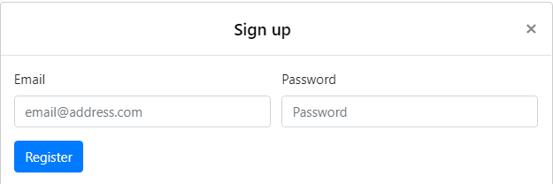

Step 13. Login
Fill out your account details
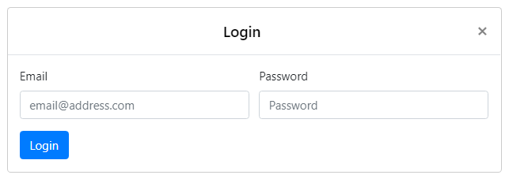

Step 14. Create a new meeting
Fill out all fields
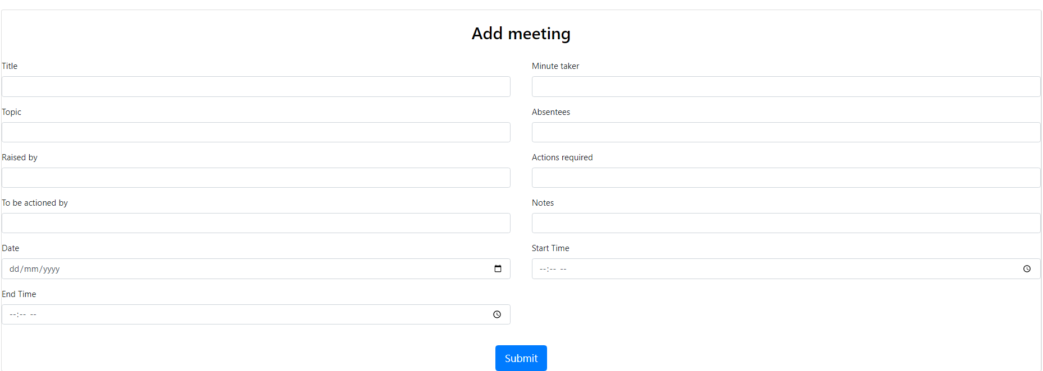

Step 15. View/Delete all meetings
View all meeting submitted by user, delete them if needed.
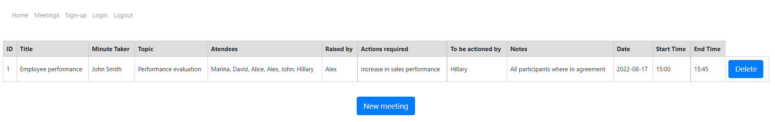

Step 16. Logout
Click the logout button

Step 17. Rerun flask app
After set up, when restarting the IDE, only steps 7 and 10 need to be executed to run the application again.

